Standing Working Group: Observatory for the History of Education
Annual Report 2020-2021

Convenors of the SWG are:
Marisa Bittar, Universidade Federal de São Carlos, Brazil, Rod. Washington Luiz, s/n, São Carlos - SP, 13565-905, bittar@ufscar.br
Thérèse Hamel, Université Laval, Canada, 2325 Rue de l'Université, Québec, QC G1V 0A6, therese.hamel@fse.ulaval.ca
Lajos Somogyvári, University of Pannonia, Hungary, Veszprém, Egyetem Street 10, 8200 tabilajos@gmail.com
Founding year:
2019
Work during 2020-2021:
The pandemic situation interrupted ongoing activities in March 2020 (preparation for the next conference and research). After restarting (in the autumn of 2020), a common publication project began, submitted February 2021, and published at Paedagogica Historica on 13 August 2021 online. As an initiative of internationalization, we exchange online guest lectures between us (May 2021, see the print screens): a Brazil presentation in Hungary and vice versa, with great success, amongst students and staff – this process has to continue further.

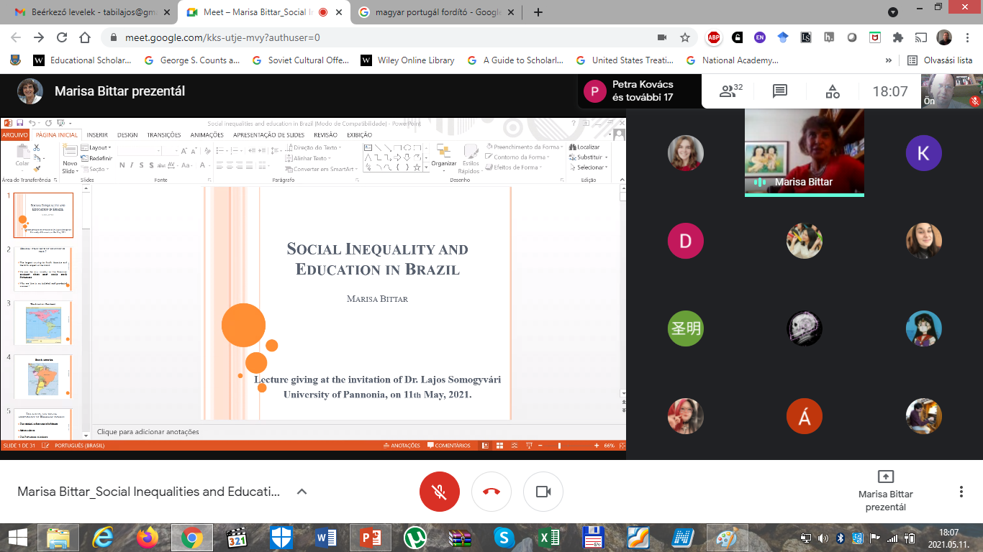

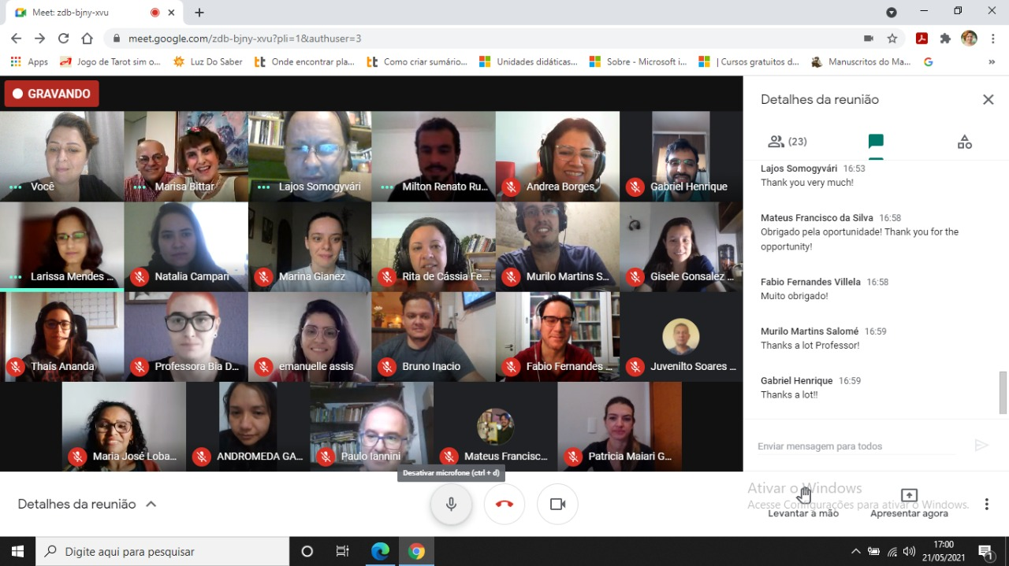
In the autumn of 2021, we began a new research plan, with colleagues from Nigeria (Grace Akanbi) and India (Krishna Kanta Roy), because of conference meetings before. This new direction will has three phases, firstly making databases, related HoE in developing countries (topicality, reception, etc.), secondly making connections to the Western, mainstream scholarship, and finally, building bridges between two worlds. A core research plan made; databases will develop in the cloud, in a common shared knowledge dissemination.
Publications, research activities:
Lajos Somogyvári, Marisa Bittar & Thérèse Hamel (2021) Observatory for the History of Education: looking at the past, analysing the present and reflecting on the future – a transnational perspective, Paedagogica Historica, DOI: 10.1080/00309230.2021.1962927. Until now, the publication has got 170 views, and mentioned six times, according to Altmetric.
After our workshop at the 2021 online conference (Theoretical and Methodological Challenges), many scholars interested toward the SWG, including:
Maria Williams, Joakim Landahl, Nicole Gotling, Brit Hovland, Ying Zhou, Dalia Survutaitė, Beatrix Vincze, Hannah Okediji, Grace Akanbi and Krishna Kanta Roy.
The impressions and lessons from workshops and sessions summarized and published online on the blog of the History of Education Society UK, due to the help of Maria Williams and Katie Carpenter: https://historyofeducation.org.uk/impressions-and-lessons-from-the-research-workshops-of-swg-observatory-for-the-history-of-education/
Group communication:
In July 2021, we started a Twitter account (https://twitter.com/SwgFor), until now, we have 66 followers and 56 tweets, making a research blog is the task of the future, it is in our plan, too.

