STANDING WORKING GROUP

GENDERING LOCAL, NATIONAL, REGIONAL, TRANSNATIONAL AND SUPRA-NATIONAL HISTORIES OF EDUCATION

ANNUAL REPORT 2020/21

Convenors
Deidre Raftery (Ireland) deirdre.raftery@ucd.ie
Stephanie Spencer (United Kingdom) Stephanie.Spencer@winchester.ac.uk
Tali Tadmor-Shimony (Israel) talits@bgu.ac.il
Kay Whitehead (Australia) kaywhitehead88@gmail.com

Originating Impetus
The Gender Group was founded in 1994 to integrate gender issues into the ISCHE conferences. Group activities ceased in 2005 because the task of successfully integrating gender into the general ISCHE conference was thought to have been accomplished. The group reconvened in 2012 to continue its activities.

Mission Statement 2018-2022
Exploring the significance of gender in histories of education has been an ongoing project in ISCHE. In this SWG, our primary goal is to articulate the significance of gender in relation to the dynamics of intersectionality in local, national, regional, transnational and supra-national historical research in education. Thus studies and conceptual approaches that investigate the relationships and entanglements between the different levels is an important dimension of our agenda. Likewise, within this approach to intersectionality the SWG is proposing to extend its remit to include research into ways in which masculinities as well as femininities interact with an array of cultural markers including race, class, age, religion and nationality.

Given that educational networks are one of the oldest forms of global connectedness, we are interested in men and women educators whose lives and work crossed borders as well as networks of correspondence, and exchanges of material goods such as books and pedagogical materials. We include activism within groups and organisations whose work transcended national borders, for example, the United Nations. In that sense we are interested in connections between women educators and international feminist networks and their intersections with men who engaged in international feminist networks.

Membership
Stephanie Spencer  Deirdre Raftery  Tali Tadmor-Simnoy  Nelleke Bakker  Kay Whitehead  Polly Thanailaki  Joyce Goodman  Ruth Watts | Dayana Lau  Florence Wenzek  Melanie Fabre  Pierre Guidi  Meng Wang  Christine Mayer  Rebecca Rogers  Adelina Arredondo | Catherine Nowlan-Roebuck Mary Clare Martin  Diana Vidal  Stephen Parker  Yuri Uchiyama  Keiko Sasaki  Liz Smyth  Sian Roberts

Report – 2020/21
- ISCHE 42: Orebro, Sweden
In 2020, 17 papers were submitted to the Gender SWG and co-convenors completed the reviews. Eight papers were selected for the two allocated panels, one paper was rejected and eight papers were redirected to other panels.

In 2021, three papers were withdrawn from the 2020 panels and the Gender SWG sponsored and chaired the following sessions online. We thank Rebecca Rogers sincerely for agreeing to chair both of the Gender SWG panels.

Panel 1 Chair Rebecca Rogers
Interrogating texts about women’s post-elementary education 1860s-1960s
ID 227 Joyce Goodman, ‘Visualising from “above” or from the margins? Defining the “university woman” and internationalising knowledge: Types of University Training (IFUW, 1934)’.
ID 376 Thomas Ruoss and Lars Heinzer, ‘Gender differences in educational attainment- Resumption of a social history approach on the example of Switzerland’s secondary education’.

Panel 2 Chair Rebecca Rogers
Women teachers transferring knowledge and practice across borders
ID 188 Tali Tadmor Shimnoy, ‘Three prototypes of the women teacher: The unmarried, the professional and the revolutionary’.
ID 373 Setsuko Kagawa, ‘From Sweden to Japan: Tokuyo Nikaido (1880-1941) and Martina Osterbergs’ training college for physical education’.
ID 395 Sayaka Nakagomi, ‘Sumi Oe’s transnational experience and the “social” role of modern Japanese women c. 1902-1912’.

Furthermore, there were several papers with a gender focus in the conference programme, attesting to the vibrancy of our field.

- Publications

Christine Mayer and Adelina Arredondo (Eds) (2020) Gender, Power Relations and Education in a Transnational World, Palgrave Macmillan.

Tim Allender and Stephanie Spencer (Eds), (2021) ‘Femininity’ and the history of women’s education: Shifting the frame, Springer Nature, Switzerland.

- Retirement

Nellleke Bakker, our colleague and Gender SWG co-convenor retired in 2020. We thank her for her many contributions to the SWG and wish her well for her future.

Planned activities - 2022
- ISCHE conference in Milan, Italy, 31 August – 4 September 2022. Kay Whitehead will continue to lead the peer-review process. The convenors will chair sessions.
- See Call for Papers overleaf.
- Deirdre Raftery and Stephanie Spencer are planning an edited volume of new work arising from the current Gender SWG.

Method of communication
The Gender SWG circulates information by email.

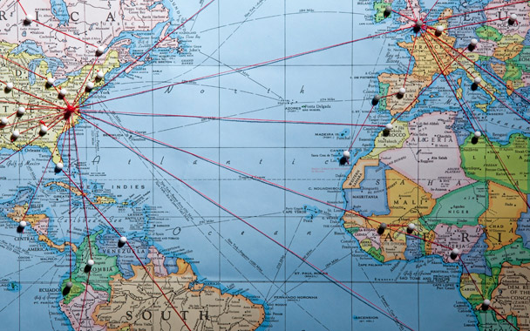 | CALL FOR PAPERS  ISCHE 2022 Gender SWG  GENDERING LOCAL, NATIONAL, REGIONAL, TRANSNATIONAL AND SUPRA-NATIONAL HISTORIES OF EDUCATION

Mission Statement of the Gender Standing Working Group for 2017-2022

Exploring the significance of gender in histories of education has been an ongoing project in ISCHE. The Gender SWG’s primary goal is to articulate the significance of gender in relation to the dynamics of intersectionality in local, national, regional, transnational and supra-national historical research in education. Thus studies and conceptual approaches that investigate the relationships and entanglements between the different levels is an important dimension of our agenda. Likewise, within this approach to intersectionality the SWG is proposing to extend its remit to include research into ways in which masculinities as well as femininities interact with an array of cultural markers including race, class, age, religion and nationality.
Given that educational networks are one of the oldest forms of global connectedness, we are interested in men and women educators whose lives and work crossed borders as well as networks of correspondence, and exchanges of material goods such as books and pedagogical materials. We include activism within groups and organisations whose work transcended national borders, for example, the United Nations. In that sense we are interested in connections between women educators and international feminist networks and their intersections with men who engaged in international feminist networks.

Gendering local, national, regional, transnational and supra-national histories of education invites submissions to the ISCHE 43 conference (31 August – 4 September 2022) in Milan, Italy. The conference theme “Histories of Educational Technologies: Cultural and Social Dimensions of Pedagogical Objects” complements our gender group’s mission statement. We are seeking papers that apply the lens of gender (alone or in conjunction with other cultural markers) and an international or transnational dimension to the conference theme.

Deadline, 31 January, 2022

Please submit abstract proposals through the conference electronic system by selecting the Gender SWG in the Abstracts area. Proposals will be submitted in English and explain briefly the research problem, objectives, theoretical and methodological approach, main primary and secondary sources, core arguments and main results. Proposals should be a maximum of 500 words, excluding bibliography. We recommend to additionally select as a second choice one of the thematic strands of the conference, so that in case of too many proposals for our SWG some may (collectively) be redirected to another strand. We intend to prepare an edited volume of gender focused papers.

